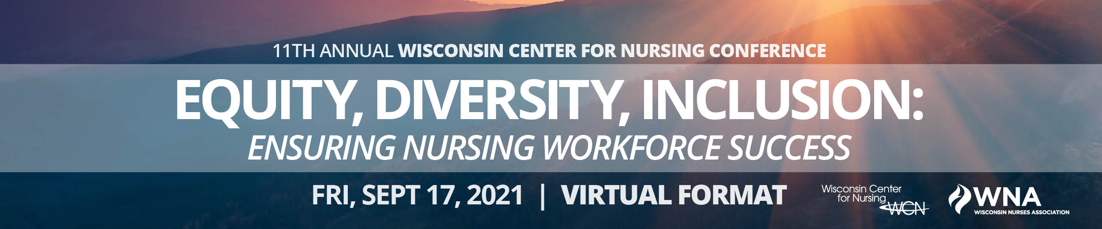
2021 SPONSOR REGISTRATION FORM

Name of organization as it should appear in materials:

Address, City, State:

Phone:

Contact for Sponsor:

Email:
SPONSOR LEVEL: All sponsorship levels include:
  - Logo included on conference materials
  - Exposure in event emails and signage
  - Registrations to the conference
  - Recognition on the WCN and Action Coalition websites
  - Acknowledgement of sponsorship on refreshment tables
  - Short 2-3 minute video to describe your organization
Please check one:
 | $10,000 | WCN Presenting Sponsor (2) - Includes the following additional benefits:  - Discussion about organization at conference opening  - Organization information, logo and video (1-2 minutes) on conference landing page  - Full page color ad in conference advertisement  - Twenty (20) registrations to the conference  - Four (4) bonus registrations to “Nurses Respond Now Priority Training Program.” **
 | $5,000 | WCN Premier Sponsor - Includes the following additional benefits:  - Opportunity to address attendees prior to a plenary session, including 5 minutes about your organization.  - Half page color ad in conference advertisement  - Ten (10) registrations to the conference  - Two (2) bonus registrations to “Nurses Respond Now Priority Training Program.” **
 | $3,000 | WCN Contributing Sponsor - Includes the following additional benefits:  - Quarter color page ad in conference advertisement  - Five (5) registrations to the conference  - One (1) bonus registration to “Nurses Respond Now Priority Training Program.” **
 | $1,000 | WCN Partner Sponsor - Includes the following additional benefits:  - Two (2) registrations to the conference
Send your organization’s logo as a .jpg or .jpeg for conference advertisement to bri@wisconsinnurses.org
The Wisconsin Nurses Association (WNA) serves as the Center’s conference coordinator.
**Bonus Registration Nurses Responds Now Priority Training: | The Covid-19 Pandemic has magnified the negative health consequences experienced by desperate and vulnerable populations. The bonus Priority Training Program will be offered at an alternate date. Registration information for the bonus program will be provided at a future time.
SPONSOR QUESTIONS: Please contact susan@wicenterfornursing.org.
WCN will invoice the contact named above. Thank you!

