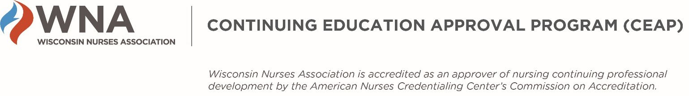

WNA CEAP IEA Applicants - Required 60‐day Post‐session Reporting

- ANCC requires information from all IEA activities to be entered in the Nursing Activity Record System (“NARS”).
- Applicants must enter required information about their activity in an online WNA information collection tool which is used by WNA to meet ANCC reporting requirements.
- For single activities, enter the information 60 days after the activity takes place.
- For single activities that are repeated one or more times for different audiences, enter the information at the end of the calendar year.
- For a “regularly scheduled series” such as hospital case conferences, enter the information at the end of the calendar year.

WHAT INFORMATION NEEDS TO BE REPORTED?
Please see the link below for information that currently needs to be reported.

WHERE DO I REPORT THE REQUIRED INFORMATION?
https://www.cognitoforms.com/WisconsinNursesAssociation/WNACEAPANCCNARSReportingForm.

REV: 1/9/22

