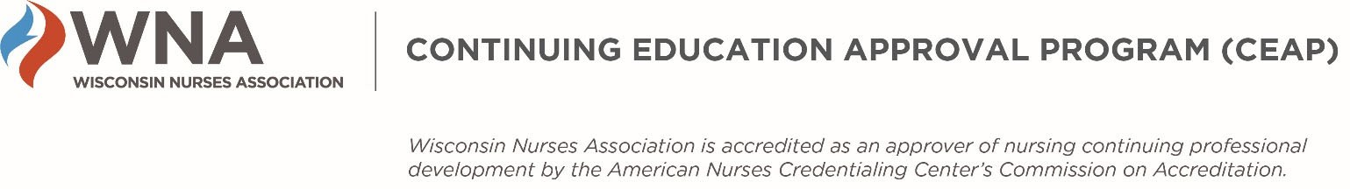

WNA CEAP IEA – Eligibility Requirements
WHEN DO I NEED TO VERIFY MY ELIGIBILITY TO APPLY?
You need to verify your eligibility as part of the WNA Application completion process.

WHAT ARE THE ELIGIBILITY REQUIREMENTS?
The following requirements must be met to apply for nursing contact hours for an educational activity. If you have questions about any of the following, please contact WNA before completing the IEA application.
- The IEA Applicant organization must not be an “Ineligible Company.” Definitions and examples are found at https://accme.org/accreditation-rules/standards-for-integrity-independence-accredited-ce/eligibility.
- Any Joint Provider (an organization working with the IEA Applicant to collaboratively plan, implement, and evaluate the educational activity) must not be an ineligible company.
- A registered nurse with a current, valid license and a minimum of a baccalaureate degree in nursing (BSN or BAN) must serve as the Nurse Planner for the activity. This nurse must be involved in all aspects of planning, implementing, and evaluating the activity, and have authority to implement and maintain all ANCC/WNA CEAP criteria.
- The activity must meet the definition of Nursing Continuing Professional Development: “Those learning activities intended to build upon the educational and experiential bases of the professional RN for the enhancement of practice, education, administration, research, or theory development, to the end of improving the health of the public and RNs' pursuit of their professional career goals” (ANCC, 2013).

HOW DO I VERIFY MY ELIGIBILITY TO APPLY?
You will verify your eligibility to apply by responding to questions in the IEA application. If you have any questions about your eligibility to apply, contact WNANPRL@wisconsinnurses.org or megan@wisconsinnurses.org before completing the application.

REV: 1-9-22

