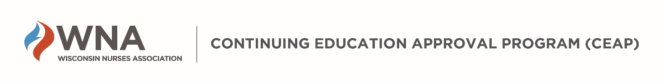

Submitting your IEA Application: Process, Fees, and Deadlines
- Three copies of the IEA Application with all attachments must be sent hard copy to:
WNA CEAP Committee
Attn: Megan Leadholm
2820 Walton Commons – Suite 136
Madison, WI 53718
- Applications must be received in the WNA office by the application submission deadline (see below for submission deadlines).
- Applications are not accepted via fax or email. Contact the WNA office with any questions.
- Number all pages of the application in sequential order from the beginning of the application to the end.
Our volunteer nurse peer reviewers and Accredited Approver Program Director refer to specific page numbers when communicating with you about the application. If WNA needs to place page numbers on your application, this takes time and adds additional cost to the review process. Hand-write the page numbers if necessary. IEA applications without sequential page numbers may not be processed.
- Complete each section of the application and attach all additional materials wherever you see this symbol: . Incomplete applications will not be processed.
- A Table of Contents is not required, but may be helpful, especially for larger applications.
- WNA will invoice the applicant organization the appropriate review fee when the application is received. Review fees may be paid by check or credit card; prompt payment is expected.
- Fees are based on the total number of contact hours available, including all concurrent (break out) sessions.
- This number may be different than the total contact hours one participant can earn.
- Please contact megan@wisconsinnurses.org for questions about payments and invoices.

