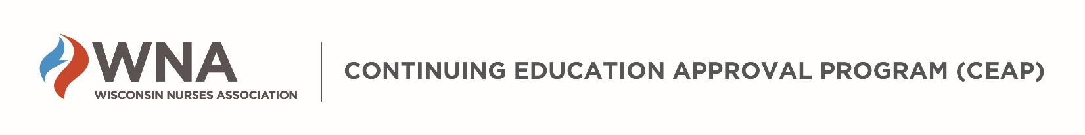

WNA CEAP IEA Application- Overview of Review Process

The Application Review Process
- Upon receipt of the application, the WNA office will send a confirmation email to the Nurse Planner (NP) and Contact (if different) indicating the application was received and an invoice for payment.
- The application and supporting materials are sent to WNA CEAP volunteer Nurse Peer Reviewers upon payment.
- WNA Reviewers will communicate any questions and need for revisions to the Nurse Planner for the activity. The NP is responsible for all aspects of the activity.
- If requested, revisions must be submitted within timeframes specified by the WNA Reviewers to avoid review delays or denial of your application.
- Application decisions are generally finalized within two weeks of the scheduled program date.
- Retroactive approval is not authorized in the ANCC accreditation system. Contact hours may not be offered for an educational activity until the applicant receives written approval from the WNA CEAP Accredited Approver Program Director (AAPD).
- WNA CEAP must be notified of and approve any proposed changes to the activity before they are implemented (e.g., change in presenter, content or time scheduled for the activity).
- WNA CEAP ensures the confidentiality of all applications and records.

IEA Application Decisions
- APPROVAL: WNA CEAP approval for an IEA is granted for two years, during which the activity can be repeated multiple times as long as the educational content of the activity does not change. Approval timeframes may be less for emerging clinical topics.
If the outcomes, content, speaker, duration of the activity, etc. changes after approval is granted, the applicant must notify WNANPRL@wisconsinnurses.org to report changes prior to the program being offered for nursing contact hours.
The WNA CEAP Accredited Approver Program Director reserves the right to audit without charge any WNA CEAP approved educational activity to monitor compliance with ANCC/WNA CEAP criteria.
- DENIAL/NOT APPROVED: If there is insufficient documentation of how the criteria are being met, the application will not be approved. If an application is not approved, the applicant may appeal the decision.
▫ Appeal: When an application is not approved by WNA CEAP, the applicant has the right to appeal the decision. Contact hours cannot be awarded retroactively; therefore, any appeal process must be initiated by the IEA applicant within 48 hours of notification of the denial by WNA. A copy of the appeal process is available upon request from the WNA office. Changes and/or revisions may not be made to the application during the appeal process. The appeal decision of the WNA CEAP Committee is final.
- REVOCATION OF APPROVAL:
▫ Activity approval and contact hours will be revoked if there is evidence that the criteria for approval were not adhered to as described in the application.
▫ Notice of revocation of approval is sent to the organization by the WNA office within two weeks of the revocation decision.
▫ The organization is responsible for notifying all participants of the revocation of contact hours as soon as possible, but not later than one month following notification of revocation.

