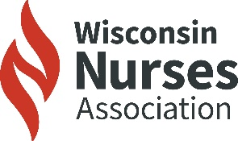
Why Wisconsin’s Nurses can benefit from a statewide clinician assistance program
WNA supports the establishment of a statewide, confidential, voluntary assistance program that encourages early help-seeking and protects both patient safety and clinician well-being.

Assembly Bill 799 and Senate Bill 802 allow for Wisconsin’s Department of Safety and Professional Services (DSPS) to contract with a selected entity that has developed a program that will; coordinate detection, evaluation, treatment, continuing care and monitoring for nurses and other health care providers who are suffering from a condition that could lead to impairment. Impairment is defined as the inability of a health care provider to practice with reasonable skill or safety due to a health condition (2025-2026 Wisconsin Legislature, 2026).

Healthcare professionals that enter this program will be provided licensure protection by not having to report their condition to their regulatory board. i.e. Board of Nursing.
AB 799 and SB 802 provide confidentially for the health care provider, who enters the support program to address alcohol abuse, substance abuse or mental health issues.

2024 Wisconsin RN Workforce Survey Data
- The 2024 RN Workforce survey shows a concerning trend: 34% of Wisconsin nurses say their health is “worse” or “much worse” after the COVID-19 pandemic (Pawlak, et al., 2025).
- Out of 66,825 nurses who provide direct patient care 37% said their health was “worse” or “much worse” during or after the COVID-19 pandemic (Pawlak, et al., 2025).
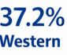
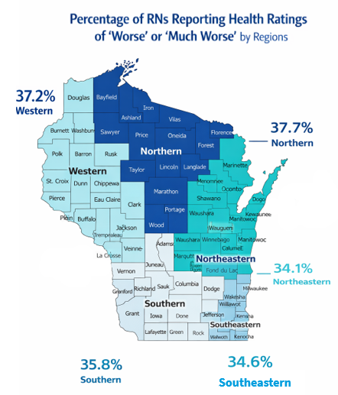

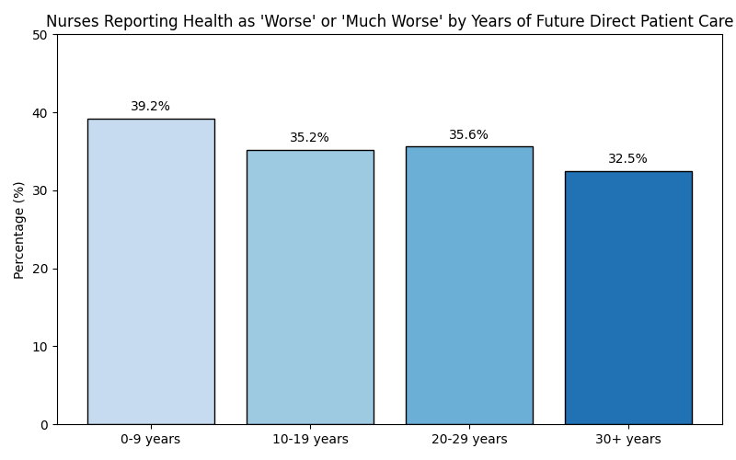

Of the 31,946 nurses who indicated they intend to continue providing direct patient care for nine years or less, 12,529—or 39.2%—reported that their health is “worse” or “much worse” (Pawlak, et al., 2025).

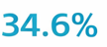
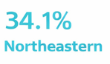
More than one-third of each of the six regions note that ratings of “worse” or “much worse”. The regions from highest note the Northern region (37.7%) followed by the Western region (37.2%) (Pawlak, et al., 2025).
Southeastern

Why Wisconsin’s Nurses can benefit from a statewide clinician assistance program

2024 WNA Wisconsin Landscape of Workplace Violence: Education, Practice and Policy Data
RNs who had reported exposure to WPV indicated that the impact on their mental health yielded burnout, anxiety, and lack of empathy. With a follow up question of interventions, it was noted that
only 8.9% reported receiving counseling or therapy (Gallagher, et al., 2024).

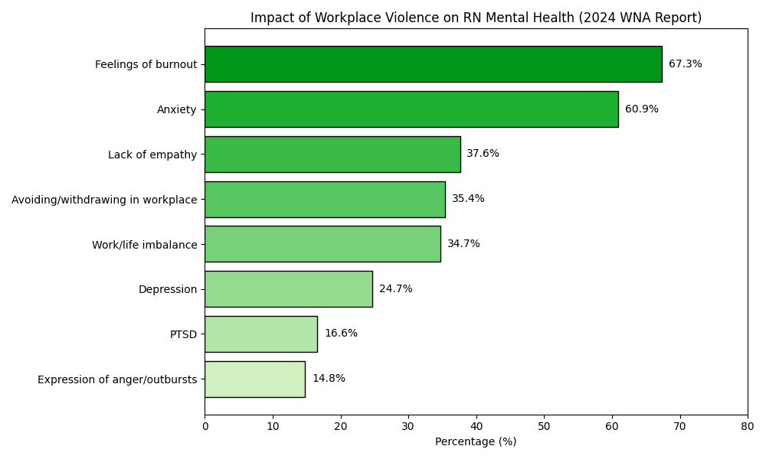
Purpose of the Clinician Assistance Program

1. Preserve voluntary, confidential access.

2. Ensure multidisciplinary and representative governance.

3. Adopt a shared-responsibility funding model $70 WNA opposes!

4. Codify continuity, data integrity, and accountability safeguards.

5. Use oversight to promote equity and quality improvement, not surveillance.

6. Demonstrates evidence-based outcomes.

2021 Healthy Nurses for Wisconsin Conference
Nurse Suicide Data

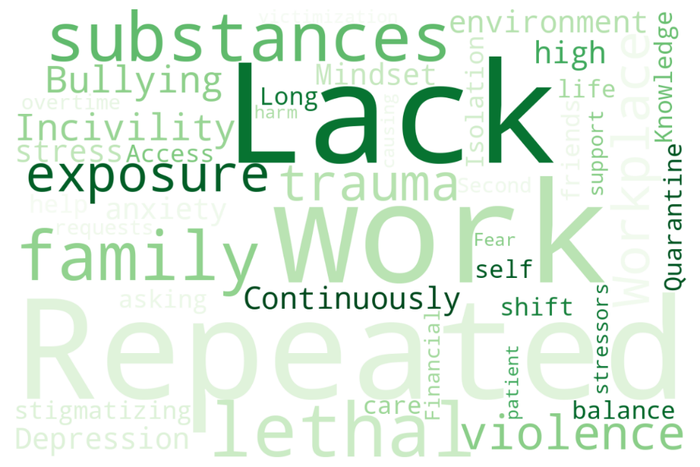

Nurse suicide is often influenced by a combination of serious precipitating factors, including repeated exposure to trauma, workplace violence such as incivility and bullying, and the strain of working in continuously high-stress environments, among many others (Wojnar, 2021).

